**Functionality Description**

**For**

**[SYSTEM NAME]**

**Date: [dd/mm/yy]**

**Contents**

**1 Document Management 3**

**1.1 *Contributors* 3**

**1.2 *Version Control* 3**

**2 OVERVIEW 4**

**2.1 Function Description 4**

**2.2 Technology 4**

**2.3 Development Tools and Processes 5**

**2.4 Interfaces and services 5**

# Document Management

## *Contributors*

*Details of all contributors to this document*

|  |  |
| --- | --- |
| **Function Integrated** | **Name** |
| Function #1 | Melvin Ng |
| Function #2 | Kua Zi Lin |
| Function #3 | Ng Chye Yong |
|  |  |
|  |  |
|  |  |

## *Version Control*

*Changes made to this document since creation.*

|  |  |  |  |  |
| --- | --- | --- | --- | --- |
| **Date** | **Version** | **Author** | **Section** | **Amendment** |
| 01/02/23 | 1.0 | Melvin | - | Initial Creation |
| 03/02/23 | 1.1 | Kua | 2.1.1 | Update Function 2 Description |
|  |  |  |  |  |
|  |  |  |  |  |
|  |  |  |  |  |
|  |  |  |  |  |
|  |  |  |  |  |
|  |  |  |  |  |

# OVERVIEW

*A brief description of what the overall system is about from a business perspective.*

## Function Description

*High level description of what functionality the system contains (a list of the components / functionalities that have been integrated (frontend ↔ backend)).*

*This should include*

*i) a sequence diagram of the input / output between the User, Front End (i.e. the Website) and the Backend (i.e. the Server App).*

*ii) screenshots of the end to end process (i.e. what would be observed by the User)*

1. **Function #1**

[xxxx]

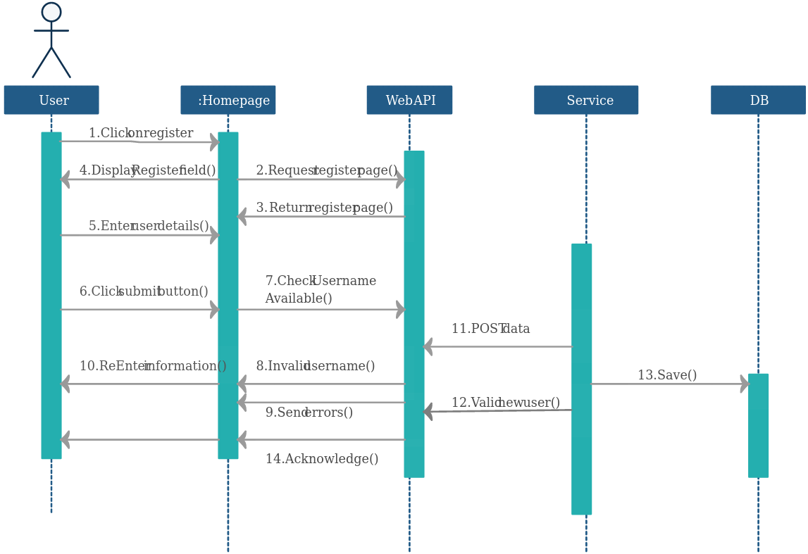

1. **Function #2 - Retrieve Movies and Sorting Z to A**

* Once the user is logged in, the user can use this function to retrieve the latest movies database from the server and display it in reverse order (Z to A).



* Before Sorting Z-A:

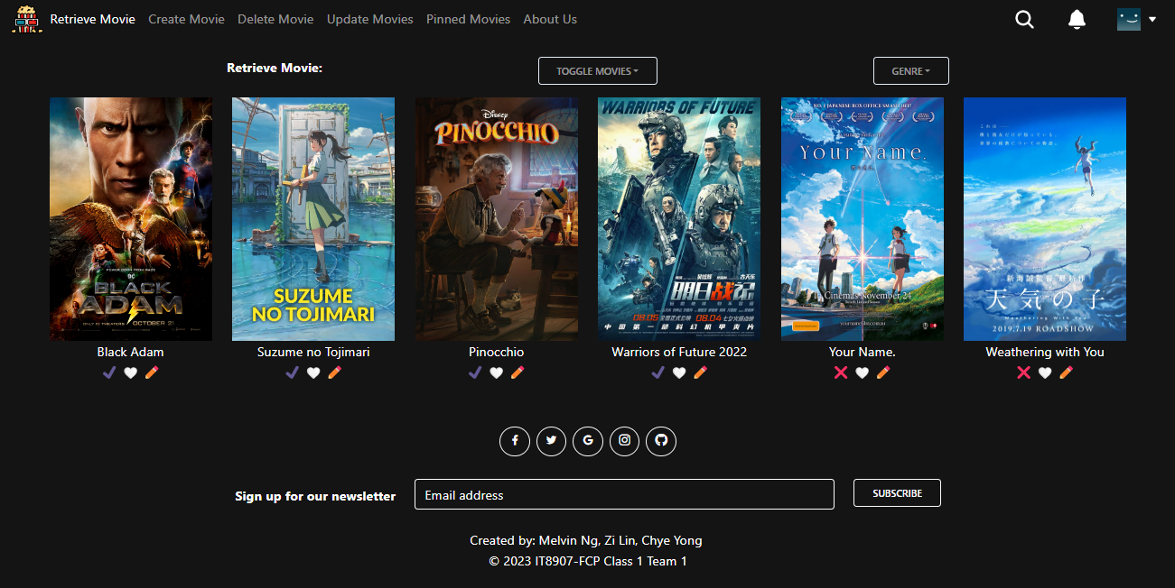

* After Sorting Z-A

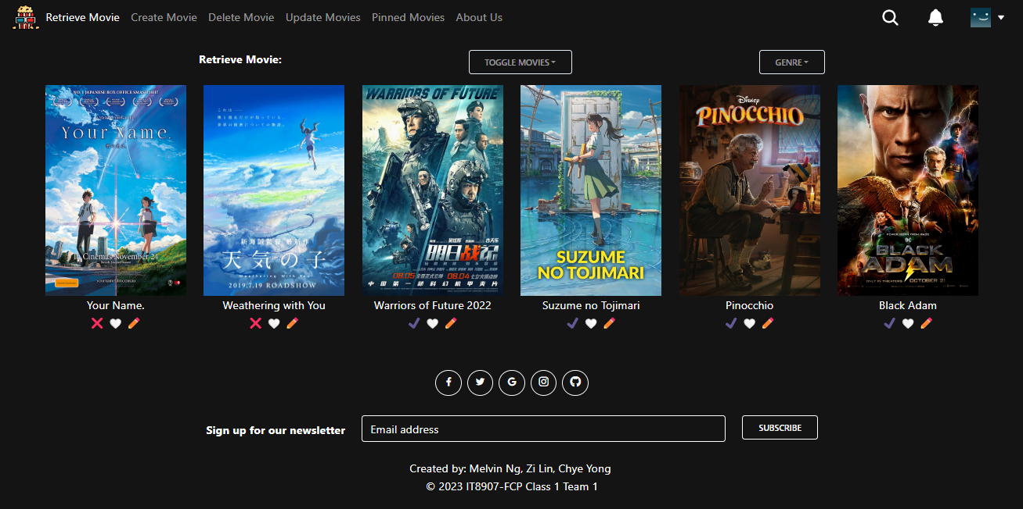

...

## Technology

*A listing and brief description of the underlying frameworks / libraries used by the application.*

## Development Tools and Processes

*This section should be used to document:*

* *any specific development tools, compilers or suggested IDEs that are used for the application.*
* *Describe how software source control is performed (e.g. Git)*

## Interfaces and services

* List all backend interfaces (incoming – data into the backend, outgoing – data out of the backend) and the path to the file (and lines of code) in which they are stored in.

| **Function Integrated** | **Details of Front End Codes** |  | **Details of Back End Codes** |
| --- | --- | --- | --- |
| Function #1 | Function.jsx (lines 20 to 30) | <-> | App.js (lines 10 to 15) |
|  |  |  |  |
|  |  |  |  |
|  |  |  |  |

# 